Deploying Content

12/02/2012 – Nick Pirocanac

# Preparing files for deployment

Place all of the files into a directory structure that mimics the on-disk location for the delivered files. For example, if you are going to deploy an update to the Beta directory for Allegiance, then you would place all files that you expect to appear in the root of the Beta directory:

C:\Program Files (x86)\Microsoft Games\Allegiance 1.2\Beta

Into a temporary directory:

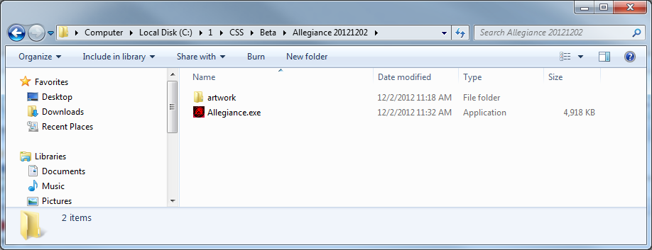

Next, use the windows “Add to Compressed Folder” to add all the files into a single .zip archive:

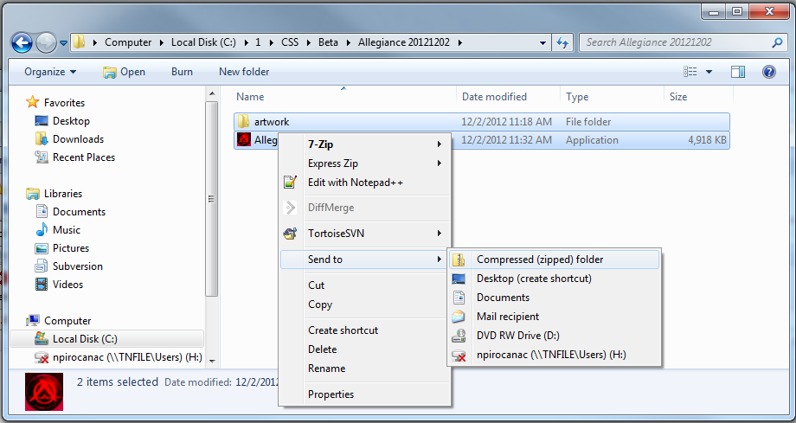

A new zip archive will appear. I typically rename them to the following convention to indicate when the archive was made and keep them in a backup directory:

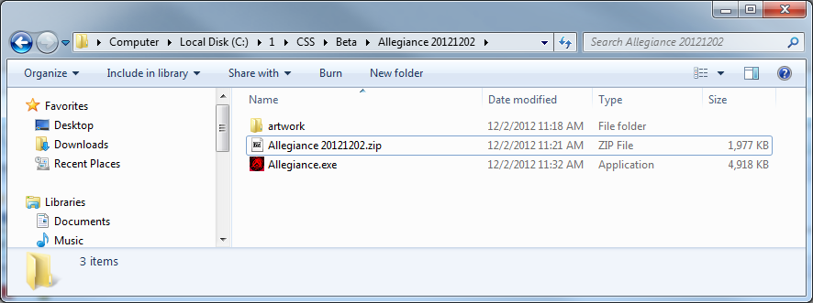

Opening up the zip file should show the following directory structure:

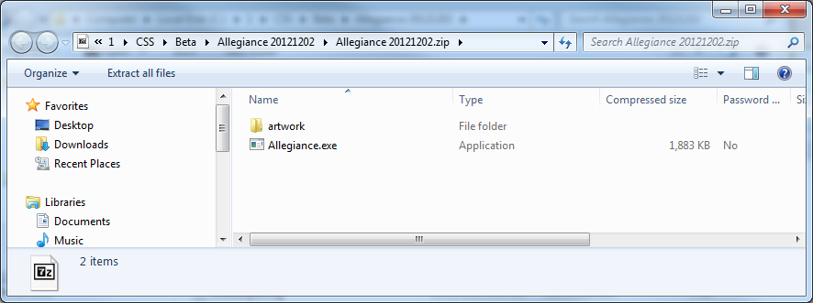

It is vital that the artwork folder appears as a subdirectory, or uploading files for the update will place the files into the wrong folders on the ACSS AU system and they will not be delivered to the right location.

# Uploading the content update to ACSS

Log into ACSS as an administrator account, and go to the Content->Auto Update section:

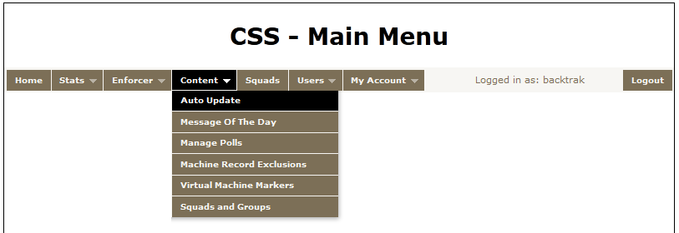

Next, you will select the package that you wish to update with the zip file created in step one. Select “Manage” to select the package:

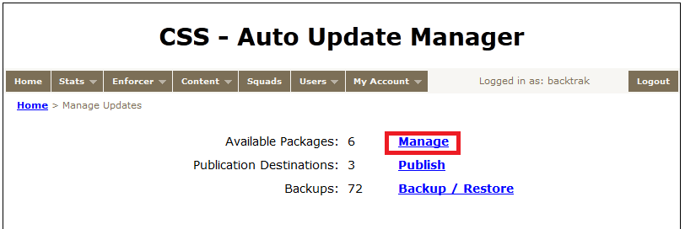

Then, select the package you wish to update. For this example, we’ll use Allegiance Beta Client. Edit the package to upload new file contents:

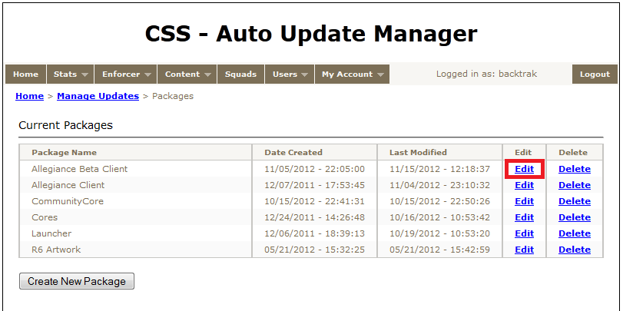

A list of all the files currently displayed in the package is displayed. Click browse to navigate to the Zip file created in step 1.

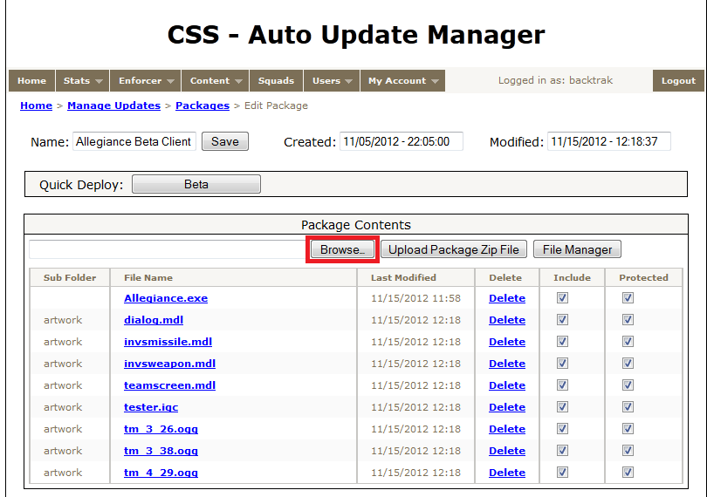

Next, click open to select the Zip file:

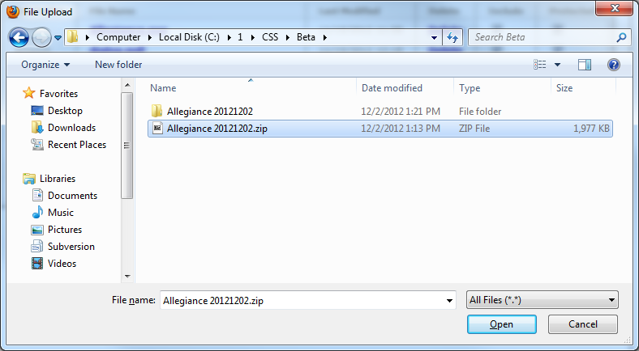

Then click “Upload” to transfer the Zip file to the server and update the package files.

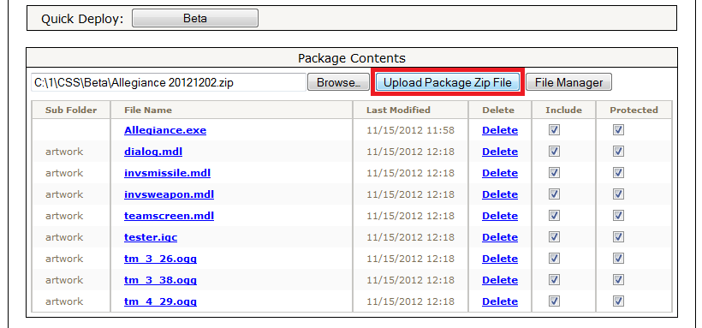

Any files in the package will be overwritten by files in the Zip file. Any files not in the Zip file will remain in the package, so if there are files you want to remove from the package you will need to delete them from the web interface. That can be done with the “Delete” link next to each file name, or in bulk from the “File Manager” button.

If you need to move files around after uploading the Zip file, or if you need to delete files, use the “File Manager” button to open the file manager for the package:

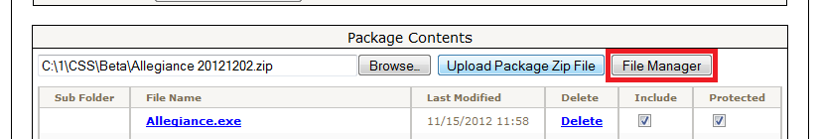

The file manager works much like any Explorer style interface. When done, click “Save Changes and Return to Package Manager” to save all of the changes. Navigating away from the file manager without explicitly saving changes will lose all changes.

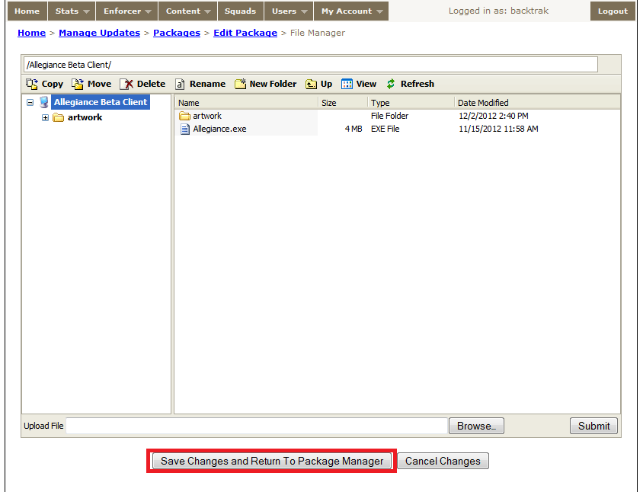

# Deploying the updated content

The easiest way to release your updated content after you have uploaded and organized it is to click the Quick Deploy button:

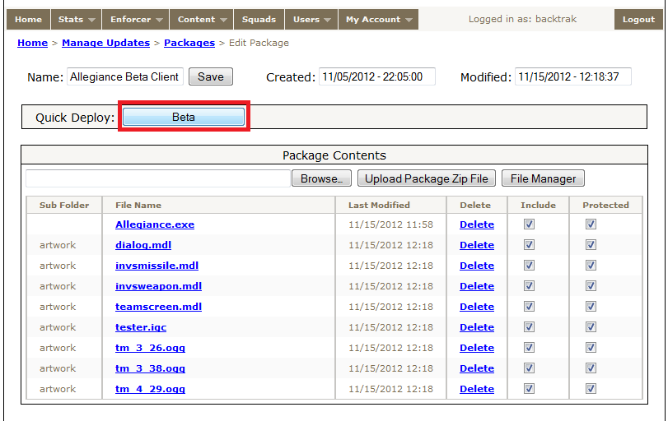

All files in the package will immediately become available on ACSS Auto Update and be downloaded by the Launcher upon login.

# If You Make A Mistake!

Backups of all publications are available from the “Backup/Restore” option in the main Auto Update menu:

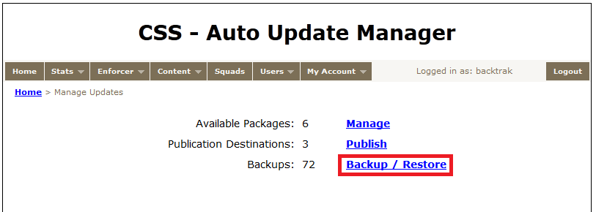

Simply select the package modification that you would like to rollback to and click “Restore”. Then, return to the package and use the “Quick Deploy” option to re-release it back to Auto Update.